Loan Proposal
28 West Water St Friendship NY 14739
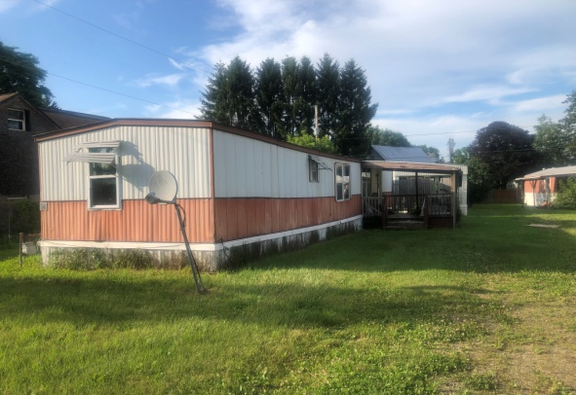
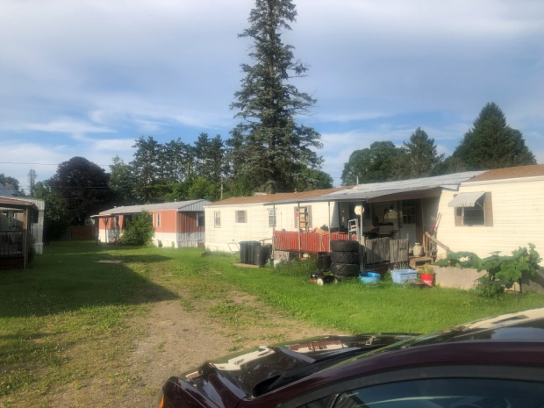
Brez Properties LLC
1994 Hardy Corners Rd
Franklinville NY 14737
John Zuech 716-353-3343

Table of contents

tab #1 about us
tab #2 the deal
tab #3 comps
tab #4 LLC documentation
tab #5 Financial Statements
tab #6 Tax returns
tab #7 credit report

About Brez Properties LLC

Brez Properties LLC is one of three llc's in our company. Rental company started with my father 35+ years ago. I became involved 23 years ago after selling cows. we currently have 48 doors , Zuech Rentals 18 doors 11 lots , JCAC Rentals 21 doors , Brez Properties 7 doors , personally 2 doors.

The Deal
Looking for investment of $70,000
$25,000 purchase price
$45,000 rehab
investment for 6 to 12 months
ARV $125,000

Offering
First position on mortgage
listed as insured
14 % interest ($816.67 interest payment / month)
Personal Guaranteed

Property consist of 4 mobile homes on village lot with public water and sewer. One home is occupied for $500 per month 3 are unoccupied .
Will rehab all 4 homes and after rehab rents will be $750/mo.
This is going to be a buy and hold property. Refi after 6 months
projected budget
income $ 750/ unit/month $3000/month $36000/yr
expenses taxes $4100 ins $700 mortgage $7088.28/yr
misc. $2000/yr
income $36000 /yr $3000/mo
expenses $13888.28/yr $1157.36
difference $22111.72/yr $1842.64

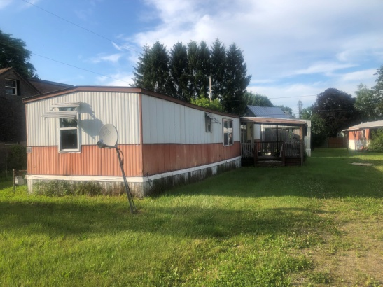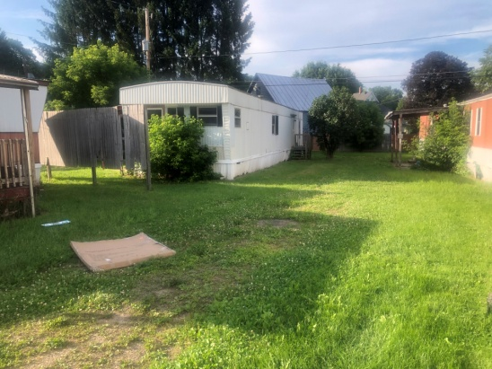
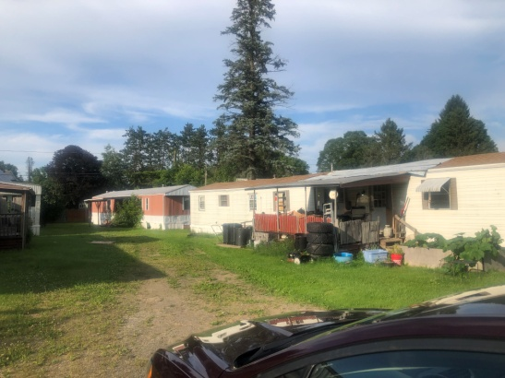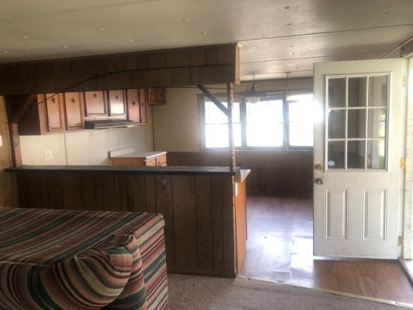
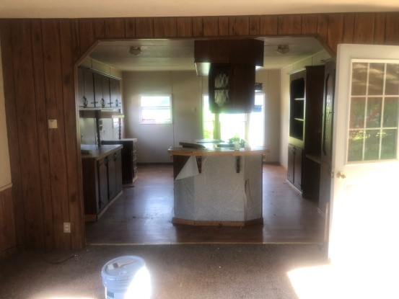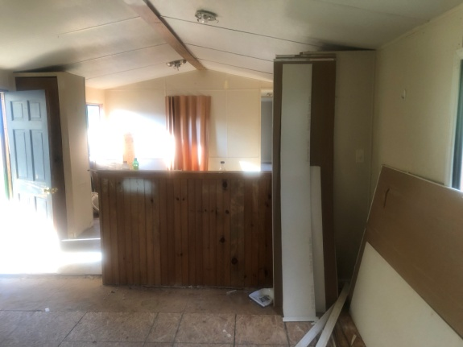

comps

subject property

28 West Water St Friendship NY full market value according to Allegany Co tax site $71600

comp info from Allegany co tax site
38 West Water St Friendship NY 1 units $34,00
4933 Maple Grove Rd Friendship NY 10 units $196,000
4440 Route 275 Friendship NY 4 units $94,700

LLC Documentation

Financial Statements and documentation
 |  |  | Brez Properties LLC
 |  |  | Financial Statement
 |  |  | as of 6/23/2023
 | Assets |  |  |  |  | Liabilities
59 North Main Delevan |  |  |  | 65000 |  | CNB Bank |  | 30650.4
17 Delevan Ave. Delevan |  |  |  | 115000 |  | home depot |  | 2183.7
79 Delevan Ave. Delevan |  |  |  | 45000 |  | visa |  | 1839.29
81 Delevan Ave. Delevan |  |  |  | 45000
tools & equipment |  |  |  | 4000
checking acct |  |  |  | 521.74
 |  | total |  | 274521.7 |  | total |  | 34673.39
 |  |  | Assets | 274521.7
 |  |  | Liabilities | 34673.39
 |  |  |  | 239848.4
 |  |  | Zuech Rentals LLC
 |  |  | Financial Statement
 |  |  | as of 6/23/2023
 | Assets |  |  |  |  | Liabilities
1103 W. Sullivan St. Olean |  |  | 1 unit | 55,000
402 5th Ave. Olean |  |  | 1 unit | 60,000 |  | PNC Bank |  | 5,098.91
104 South Main St. Delevan |  |  | 1 unit | 70,000 |  | CNB bank |  | 36,788.72
8719 Rte. 16 Franklinville |  |  | 1 unit | 30,000
3008 Smith Hollow Allegany |  |  | 4 unit | 150,000 |  | Mr. Copper |  | 39,991.45
1680 Allegany St. Allegany |  |  | 1 unit | 30,000
315 N 12th Olean |  |  | 3 unit | 120,000 |  | CNB Bank |  | 35,403.79
1440-1474 Four Mile Allegany |  |  | 18 lots | 315,000 |  | Hamlin Bank |  | 250,000.00
 |  |  | 1house
tools &equipment |  |  |  | 5,000 |  | home depot |  | 786.29
checking acct. |  |  |  | 3,085.01 |  | visa |  | 4,327.85
One America life ins |  |  |  | 9,692.78
 |  | total |  | 847777.79 |  | total |  | 372397.01
 |  |  | Assets | 847777.79
 |  |  | Liabilities | 372397.01
 |  |  | Net worth | 475380.78

 |  |  | JCAC Rentals LLC
 |  |  | Financial Statement
 |  |  | as of 6/23/2023
 | Assets |  |  |  |  | Liabilities
42 Grove St. Delevan |  |  |  | 130000 |  | Bank of Holland |  | 364051.4
621 East State St. Olean |  |  |  | 100000
318 South 2nd St. Olean |  |  |  | 100000
223 South 3rd St. Olean |  |  |  | 100000 |  | home depot |  | 2969.88
1116-1122 W. Sullivan Olean |  |  |  | 125000 |  | visa |  | 1863.4
124 N. Barry |  |  |  | 125000
126 N. Barry |  |  |  | 15000
201 N. Clinton |  |  |  | 80000
313 Coleman |  |  |  | 75000
tools &equipment |  |  |  | 13000
checking acct. |  |  |  | 1062.59
 |  | total |  | 864062.6 |  | total |  | 368884.7
 |  |  | Assets | 864062.6
 |  |  | Liabilities | 368884.7
 |  |  | Net worth | 495177.9

 |  |  |  | John Zuech
 |  |  |  | Financial Statement
 |  |  |  | as of 6/23/2023
 |  | Assets |  |  |  |  |  |  |  |  |  | Liabilities
 | 1994 Hardys Corner Rd. |  |  |  | 138000 |  |  |  | Community Bank |  |  |  | 36899.49
 | 2068 Hardys Corner Rd. |  |  |  | 34000 |  |  |  | CNB bank |  |  |  | 14085.18
 | 340 Congress St. |  |  |  | 45000 |  |  |  | ally |  |  |  | 8766.39
 | Autos |  |  |  | 16000 |  |  |  | penfed |  |  |  | 20988.74
 | tools &equipment |  |  |  | 5000
 | checking acct. |  |  |  | 1594.41
 | mass mutal |  |  |  | 9913.52
 |  |  | total |  | 249507.9 |  |  |  | total |  |  |  | 80739.8
 |  |  |  | Assets | 249507.9
 |  |  |  | Liabilities | 80739.8
 |  |  |  | Net worth | 168768.1
Tax Returns
2019,2020,2021 1 page federal included
full tax returns are available upon request

Credit Score

